**OODP Assignment**

Avik Prasad - RA2011030010079

Raagul Vignesh - RA2011030010088

Pasumarthi Madhava Venkata Pranav - RA2011030010103

**Airline Reservation System**

Airline Reservation System is a system that allows booking tickets on flights. The system also contains information about the schedule, fare and the availability of the seats in the flights. A user of this system can be basically of two types – a passenger or an employee. A passenger who wants to book a ticket for any particular flight, first should login into the system. If he or she does not have an account, first an account should be created then the ticket can be booked using the system. For the booking to get confirmed, the passenger has to do the payment for the seats booked. After completing payment, the seats allotted are sent to the passenger. The passenger can also update their profile, change password, search for flight timings, seats availability, view the booked ticket, cancel any booked ticket. The employee can manage the users of the system, airlines, reservation, and passengers. For performing these tasks, admin also has to login into the system. The admin also can update their details, change the password.

**Class Diagram**

The class diagram depicts a static view of an application. It represents the types of objects residing in the system and the relationships between them. A class consists of its objects, and also it may inherit from other classes. A class diagram is used to visualize, describe, document various different aspects of the system

In class diagram there are different types of class like user, passenger, employee, booking,

Payment etc. Customer and Employee both can login with the same user to book tickets. While booking the tickets customer can view the details like timings,type of aircraft etc.Those who have booked tickets have to make the payment to confirm the reservation.

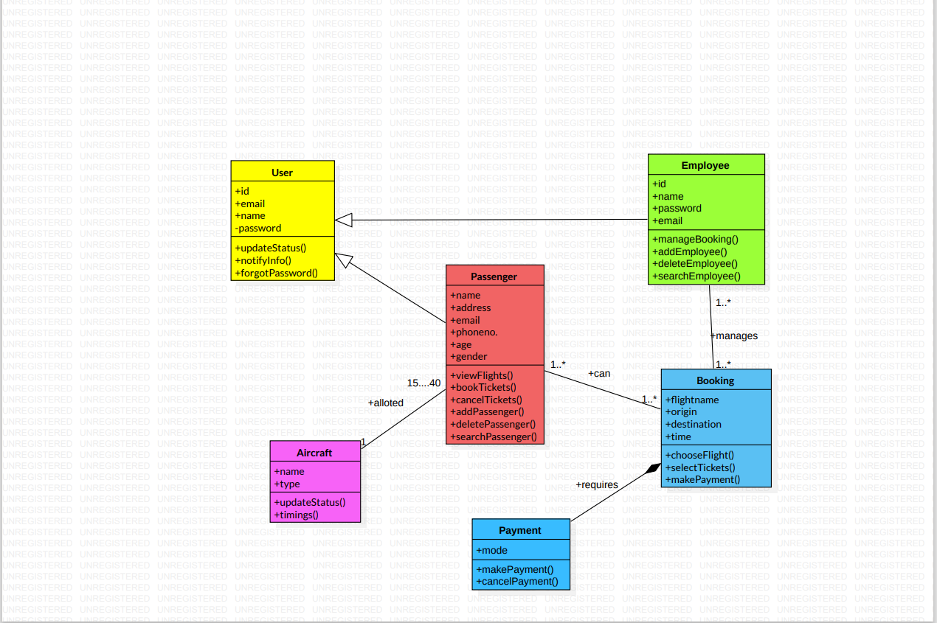

**Use Case Diagram**

The use case diagram is the diagram that helps us know the various interactions that can take place between the user and the system. In this case the actor called ‘passenger’ can use the following cases:

1. book tickets

2. cancel tickets

3. update profile

4. change password

But to use these cases the passenger must login into the system. That is mandatory.

In case for the ‘employee’ actor, the various use cases are:

1. manage tickets

2. update schedule

3. change his/her account password

4. update profile

The employee also must first logon into the system to perform the use cases.

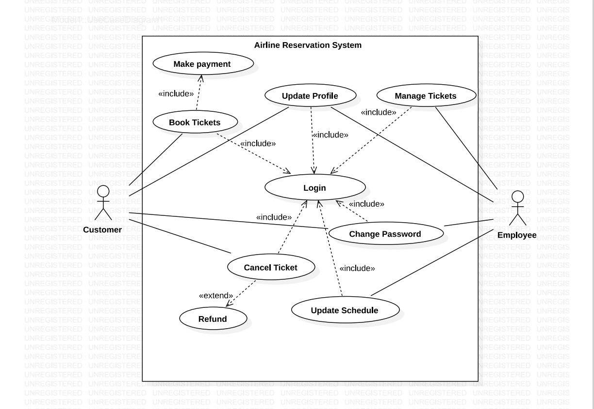**UML dynamic Modeling**

Dynamic Modeling can be represented by the following diagrams.

* Behavior Diagram
  + Sequence Diagram
  + Collaboration Diagram
* State chart Diagram
* Activity Diagram

**Sequence Diagram**

A sequence Diagram simply depicts interaction between objects in a sequential order i.e the order in which these interactions take place.

We have made different lifelines as Customer, Login,Booking System, Flight Details and Reservation System. First Customer will login to the portel and it gives a reply message as login successfully. After login Customer searches for flights. The booking system sends a message to the Flight Details and it shows matching flights. Booking system shows the flights and their cost. Then Customer enters the passenger details and selects the seat.It gives the entire summary.

After completing the requirements, make payment and confirm the reservation. The system generates the ticket.

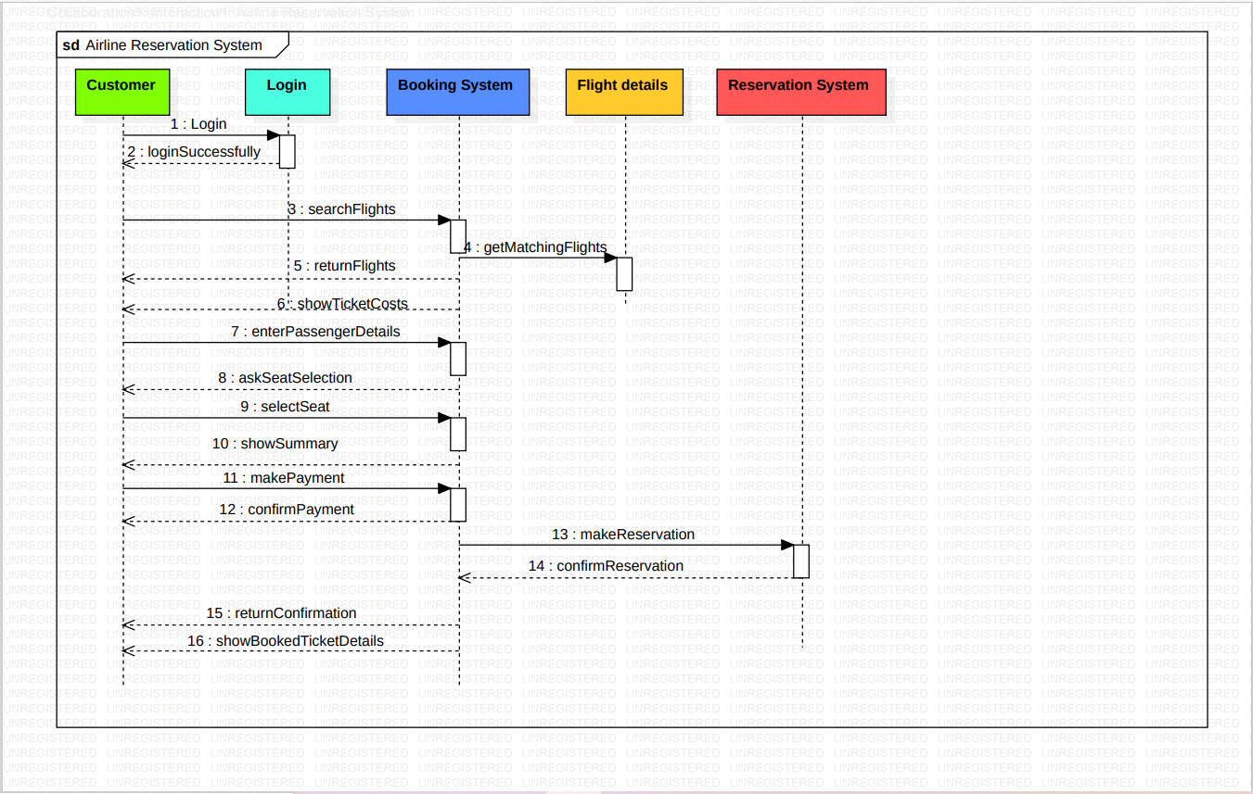

**Collaboration Diagram**

Collaboration Diagram depicts the relationships and interactions among software objects. They are used to understand the object architecture within a system rather than the flow of a message as in a sequence diagram. They are also known as Communication Diagrams.

Life Line is like a participant in a Collaboration Diagram. There are three life lines: Customer, Booking System and Reservation System. First Customer will login to the booking system. After login, customers will search for flights. Then he/she enters the passenger Details,select seats. After completion all customers make payment and the booking system generates ticket.

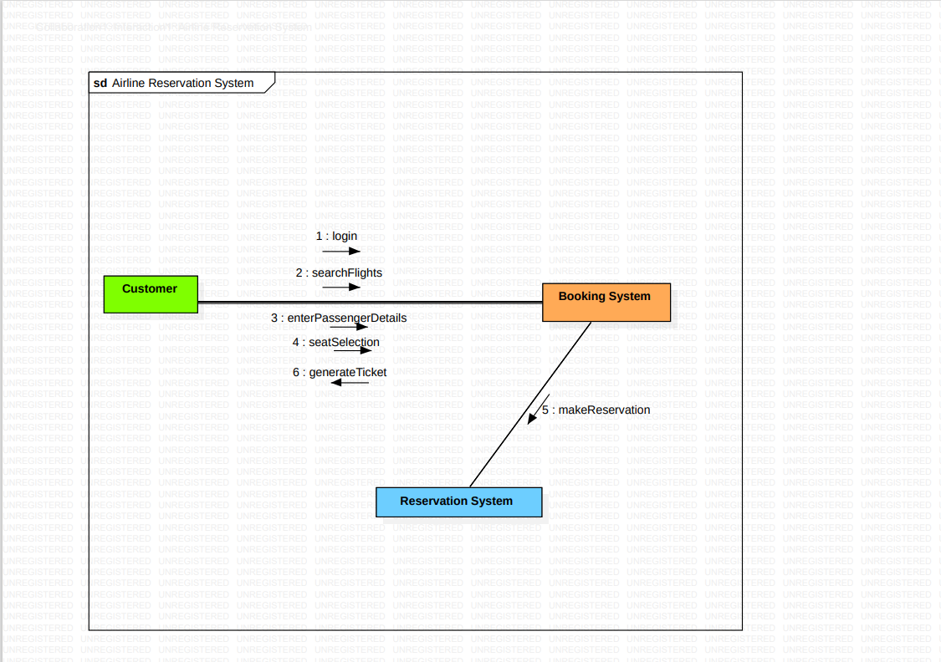

**State chart Diagram**

A State Diagram is used to represent the condition of the system or part of the system at finite instances of time. It's a behavioral diagram and it represents the behavior using finite transitions.

First Customer logins to the system.If all the credentials are correct then it proceeds. If not it gives a message as Invalid Credentials it goes to the login page.

If login successfully then we can search for flights.After searching Customer have to enter passenger details then select seats.After completion of all these processes Customer will make payment and confirm the reservation. At last the system generates ticket.

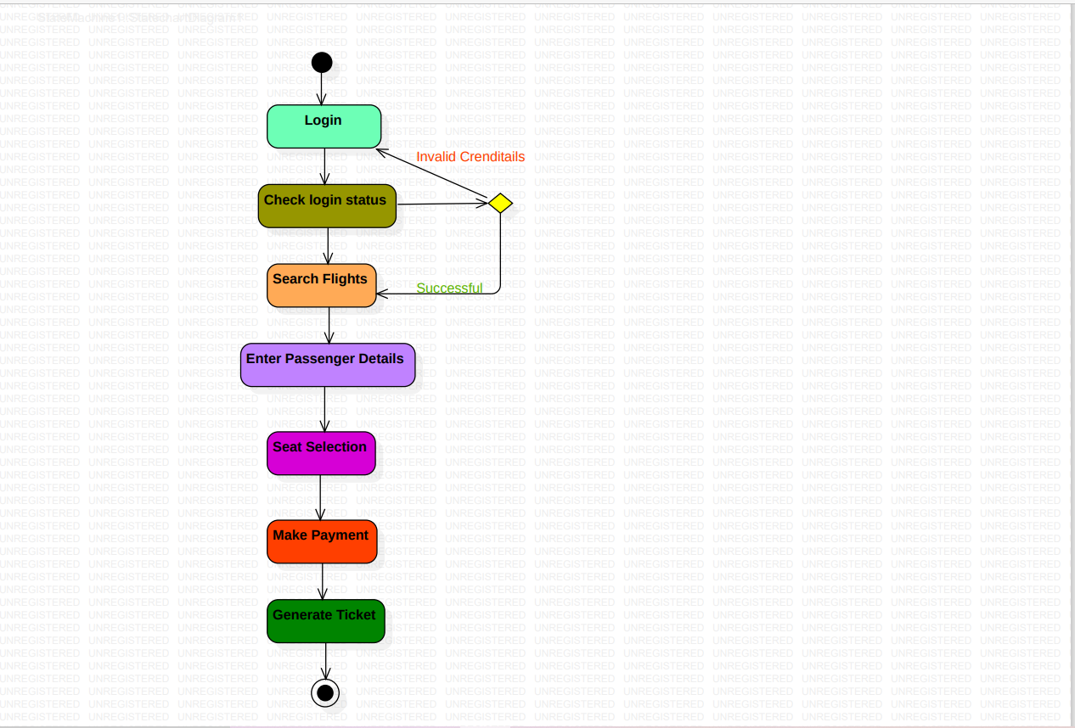

**Activity Diagram**

Activity Diagram is basically a flowchart to represent the flow from one activity to another activity. The activity can be described as an operator of the system. It is used to show message flow from one activity to another.

Customer and Booking System are two swimlanes. First Customer will login to the portel. Then he searches flights. Booking system shows the flights and the Customer selects the flight and he enters the required details and selects seats. After completion of all requirements Customer will make payment .Booking system generates ticket and the customer receives ticket.

